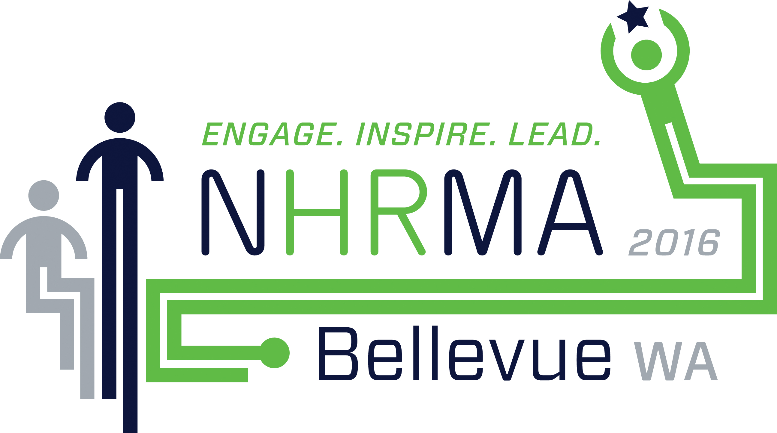
NHRMA 2016 Conference & Tradeshow
September 7-9, 2016 | Bellevue, WA
Pre-Registered, Adding Optional Items ONSITE REGISTRATION
PARTICIPANT INFORMATION: Please print legibly. Complete one form per person.

First Name: ________________________________ Last Name:________________________________________________________
Organization: _________________________________________________________________________________________________

ADDITIONAL ITEMS FOR PURCHASE:
Pre-Conference Workshop (Wednesday, Sept 7) $119.00 = __________________
Name of Workshop: ______________________________
Evening Event: Bowling (Thursday, Sept 8) $40.00 = __________________
Guest Evening Event Ticket $40.00 = __________________

TOTAL PAID = $ _______________________
PURCHASER INFORMATION:
Cardholder Name (As it Appears on Card): ______________________________________________________________________
Billing Address: _________________________________________________________________________________________________
City:_________________________________ State/Province: ______________ Postal Code _______________________________
Type of Card: Visa MasterCard AmEx Card Number: ________________________________________
Expiration Date: _____________________________________ Security Code: ___________________________________________
Authorized Signature: ___________________________________________________________________________________________

MUST BE COMPLETED AND RETURNED TO:
CONFERENCE REGISTRATION & INFORMATION DESK
MEYDENBAUER CENTER, CENTER HALL LOBBY
DURING REGISTRATION HOURS BEGINNING SEPTEMBER 7, 2016

